

Construction Company Ajman
General Contracting Services Ajman
Commercial Construction Ajman
Residential Construction Ajman
Building and Construction Services Ajman
Top Construction Companies Ajman
Ajman Civil Engineering Contractors
Industrial Construction Services Ajman
Construction Management Ajman
Custom Building Services Ajman
Infrastructure Development Ajman
Affordable Construction Services Ajman
Building Renovation Contractors Ajman
Turnkey Construction Solutions Ajman
Sustainable Construction Ajman

Meta Title:
Reliable Construction Company in Ajaman
Meta Description:
MAP Building Contracting LLC is among the leading construction companies that stand out in the Ajman market due to its sustainable solutions and sound decisions.

Superior Quality

Constructing Dreams With Innovation
Welcome to MAP Building Contracting LLC, where construction ideas are shaped into reality through the power of innovation, technology, and sound decisions.

View Projects! | Hire Us Now!



Sustainable Solutions | Sound Decisions | Remodeling Experts
Here at MAP Building Contracting LLC, we offer Turnkey Construction Solutions in Ajman by opting for green materials. Moreover, we also implement the best energy-efficient practices to reduce cost and increase quality during construction. | Our Ajman Civil Engineering Contractors help to make sound decisions by providing all relevant information related to the decision-making process and project plans. From identifying problems to measurable outcomes, you have our expert back. | We have the best team of Building Renovation Contractors in Ajman with strong expertise in design as well as construction. From managing architecture to construction designs and interior designs to sound decisions, you can rely on us.

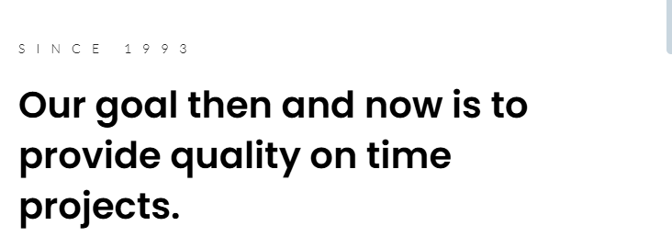

Since 2010

Your Trusted Construction Company in Ajman, UAE!
MAP Building Contracting LLC is among the Top Construction Companies in Ajman that offers Affordable Construction Services for both national and international clients. Our rich portfolio of work has some of the most elegant and sophisticated modern masterpieces of properties at the heart of Ajman.
For more than 15 years, our Construction Management Ajman company has shaped the skyline of the main areas of Ajman such as Al Rashidiya, Al Hamidiyah, Al Nuaimiya, Al Zahya, Al Heilio, Emirates City, Al Zaheya Gardens, Al Rawda, Al Mowaihat, and Hadhf. At MAP Building Contracting LLC, we have set the infrastructure of landmark industrial, residential, and commercial projects. Our primary focus is to maintain the superior quality and highest safety standards without compromising on the quality.

View Our Projects!

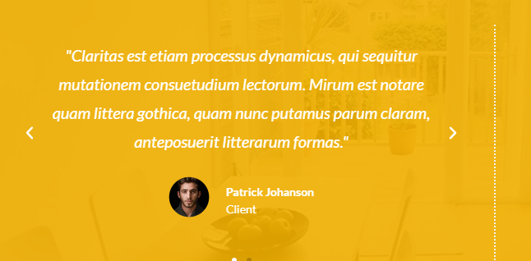

Testimonial 1:
MAP Building Contracting was our contractor for the new office building in Ajman and I can’t express enough how satisfied we are. Their team can be described as professional, experienced, and highly careful at every stage of the work. They built our beautiful modern structure not only within the expected time frame but also below the expected costs. Based on our experience, we will strongly endorse MAP as the contractor of any commercial construction.

Testimonial 2:
I have been an architect in the past and have worked closely with many construction companies, however, none have offered such excellent work and quality service with which MAP Building Contracting comes. In the recent house project that I undertook, they were excellent in realizing my design concepts. Their communication was coherent, the work rate extraordinary, and the tidiness of services provided unsurpassable. All in all, I will be advising all my clients to use them going forward.

Testimonial 3:
I am a developer in Ajman and for the last ten years, the MAP Building Contracting LLC team has been working for me on more than a dozen contracts connected with differentiated construction works – from private villas of the luxury class to small apartments, business buildings, and offices. The projects they deliver to my buyers always draw modern clean lines and strong engineering. I believe they are a strategic, long-term partner for the development of Ajman and the UAE.



Latest Trends and Insight about Real Estate Market:
Check out our latest blogs to get a proper insight into Prices, Location, Public Policy, and interest rates of Real Estate Marketing.



MAP Building Contracting LLC is the proud Infrastructure Development Company in Ajman and the recipient of several national as well as international awards. For more than 15 years, we have been serving this industry and set the standard of construction high with our utmost dedication to quality services, effective management, Proficiency, and timely execution.

